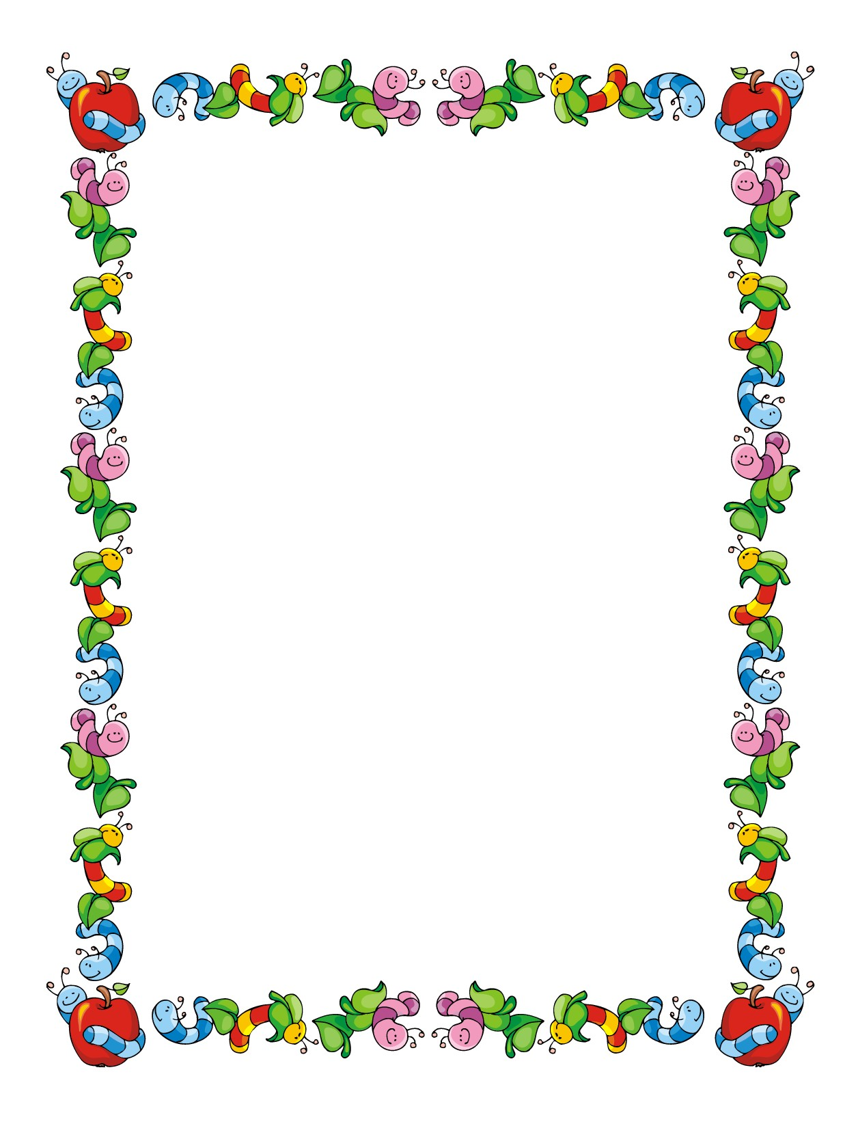

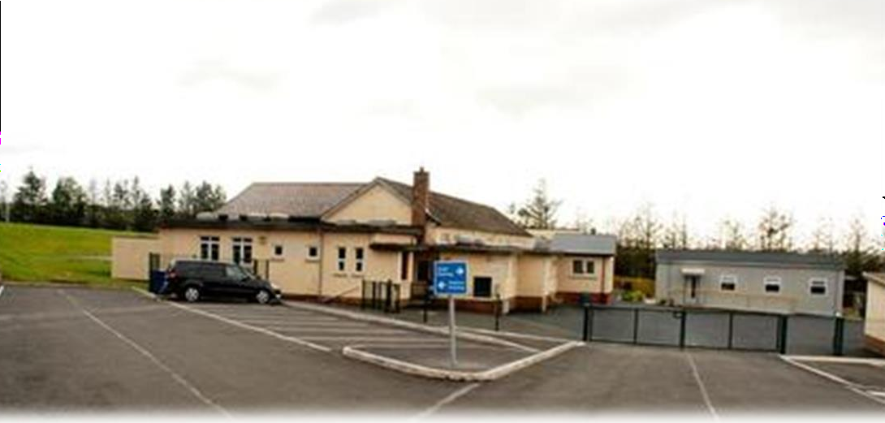

www.stmarysprimarydunamore.co.uk

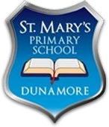
St. Mary’s Primary School
40 Dunamore Road • Cookstown • Co. Tyrone • BT80 9NT
Tel: 028 8675 1357
Principal: Mrs Eileen Ward B.Ed. (Hons) M.Ed., PQH (NI) Email: eward387@c2kni.net www.stmarysprimarydunamore.co.uk

Dear Parents/Guardians,

Welcome to St. Mary’s Primary School.

St. Mary’s is in the parish of Kildress serving the community through the provision of a caring and effective Catholic education service, which enables children to make the most of their potential.

We are delighted your child will be starting Primary One at St. Mary’s in September. Our aim is to make your child’s transition into Primary One a happy and enjoyable experience.

I hope you find this ‘Welcome Booklet’ informative. It is designed to provide you with information about our school to enable you to become familiar with our aims and how we work for and with your children.

Our school is a happy family environment, hardworking and successful. The child is at the centre of everything we do. Our whole school community shares one common goal: - to do the very best for all the children in our care. Your child will be made most welcome and I trust the next seven years will be happy and rewarding.

Good relationships between home and school form the basis of school life. Please contact us with any queries you may have. We look forward to working with you. If you have any questions or concerns, please feel free to contact myself directly.

Yours sincerely Mrs Eileen Ward
Principal

We the Governors and staff of St. Mary’s Primary School believe the school to be a vital part of the Catholic Community. We are firmly committed to:
the aims of Catholic education.
Providing effective education for all our children.
Developing positive pastoral care systems in our school.
Establishing close links with the home, the parish and the wider community.

St. Mary’s seeks to establish a caring community centred on Christ, so that His values and gospel message pervade the whole life of our school.

In St Mary’s we work together, to provide an educational experience within a caring community in accordance with our Catholic faith

We strive to enable children to achieve their potential in a secure and positive learning environment that equips them with life-long skills, knowledge, beliefs, values, attitudes and qualities that allow for continuing spiritual, emotional and intellectual growth.

We aim:
- To provide a broad and balanced curriculum which fulfils the requirements of the Revised Curriculum.
- To become highly motivated independent learners.
- To achieve high standards in all areas of the curriculum.
- To promote and maintain the Catholic ethos of the school whilst developing respect and tolerance for other creeds.
- To develop each individual child spiritually, morally, intellectually, socially, emotionally and physically, so that by realising his/her potential he/she can have an appreciation of his/her self-worth.
- To take responsibility for their own learning as they grow into reliable independent and positive citizens.
- To encourage our parents to play a supportive role in the life of the school.

School Address: St. Mary’s Primary School.
40 Dunamore Road, Cookstown.
Co. Tyrone BT80 9NT

Telephone: 028 86751357

Email: info@stmarys.dunamore.ni.sch.uk

Website: www.stmarysprimarydunamore.co.uk

STAFFING 2023/24

Principal

Mrs Eileen Ward

Teaching Staff

Primary One: Mrs Ursula O’Hanlon Primary Two: Mrs Claire Toner Primary Three: Mrs Julie McAllister Primary Four: Mrs Shaunagh Devlin Primary Five: Mrs Fiona McCormick Primary Six: Mr Keith Herbert
Primary Seven: Mrs Jane-Marie Mallon

Non-Teaching Staff

Mrs Edel McGlinchey Mrs Paula Jackson

Mrs Paula O’Kane

Mrs Kathleen McGuigan Mrs Anne-Marie McAuley

Senior Clerical Officers

Miss Anne McGarrity Miss Niamh Armstrong

Building Supervisor

Mrs Martina Mallon

Lunchtime Supervisors

Miss Anne McGarrity Mrs Martina Mallon Mrs Edel McGlinchey Mrs Paula Jackson Mrs Paula O’Kane
Mrs Kathleen McGuigan Mrs Anne-Marie McAuley

Head Cook

Mrs Eilish Donnelly

Assistant Cooks

Mrs Mary-Angela McGurk Mrs Ita Ferry

Cleaning Staff

Mrs Mary-Angela McGurk Mrs Ita Ferry

Board of Governors

Representing
Department of Education: Mrs D McCrory

Education Authority: Mr S Forsythe Mr C McCarney

The Parents: Mrs M McGurk

The Staff: Mrs U O’Hanlon

The Trustees: Rev. Fr. P Hughes PP Mrs C Kelly
Mr M Slevin Mrs E Keenan

The School Principal (Mrs Eileen Ward) acts as Secretary to the Board of Governors who meet regularly throughout the year and have responsibility for the management of St Mary’s.

All contact with the Board of Governors is through the school.

St Mary's Primary School Maintained Primary School 40 Dunamore Road
Cookstown Enrolment Number: 189
Co. Tyrone Admissions Number: 27
BT80 9NT
PRINCIPAL: Mrs E. Ward BEd (Hons) M.Ed PQH CHAIR OF BOARD OF GOVERNORS: Fr Hughes

Telephone No: (028) 8675 1357 Email: eward387@c2kni.net

The Board of Governors draws up the admissions criteria and delegates to the Principal, the responsibility for applying these criteria. Any reference herein to the term the Board of Governors includes the Principal appointed by the Board of Governors for the purposes of applying the admissions criteria.

ADMISSIONS CRITERIA

During the admissions procedure when applying the criteria punctual applications will be considered before late applications are considered. The application procedure opens on 10 January 2023 at 12noon (GMT) and an application submitted by the closing date of 27 January 2023 at 12noon (GMT) will be treated as a punctual application. An application received after 12noon (GMT) on 27 January 2023 will be treated as a late application.
Priority will be given to children who will have attained compulsory school age at the time of their proposed admission.

In selecting children for admission, children resident in Northern Ireland at the time of their proposed admission will be selected for admission to the school before any child not so resident.

The Board of Governors will apply the following criteria in the order indicated to identify which children should be admitted either at initial admission to education or on transfer from another school.

- Children who reside in the Parish of Kildress.
- Children who will have brothers or sisters, half-brothers or half- sisters in attendance during the 2022/2023 school year.
- Preference will be given to children with exceptional circumstances (medical, social or other problems) that necessitate admission to St Mary’s Primary School, Dunamore rather than any other primary school. The circumstances should be personal to the child and must be supported by independent and appropriate documentation, providing evidence of the circumstances being described as being exceptional.
- The remaining places will be allocated on the basis of the proximity of the child's home to the school, priority being given to those living nearest to the school. Distance will be measured by Google Maps UK driving distance.
- If the final places to be allocated have identical measurements as identified by Google Maps UK, selection will be on the initial letter of surname (as entered on birth certificate) in order to be set out below:
F M C O R E G Z Y I L X U D K W N P H A S T V Q B

This order was determined by a randomised selection of letters. In the event of surnames beginning with the same initial letter the subsequent letters of the surname will be used in alphabetical order. In the event of two identical surnames the alphabetical order of the initials of the forenames will be used, if necessary the subsequent letters of the forenames.

Criterion 5 will also be used to discriminate within any oversubscribed criterion.

DUTY TO VERIFY

The Board of Governors reserves the right to require such supplementary evidence as it may determine to support or verify information on any application. If the requested evidence is not provided to the Board of

Governors by the deadline given, this will result in the withdrawal of an offer of a place. Similarly, if information is supplied which appears to be false or misleading in any material way, the offer of a place will be withdrawn.

WAITING LIST POLICY

All unsuccessful applications will be placed on a waiting list. Should a vacancy arise after 27 April 2023 all applications for admission to Primary 1 that were initially unsuccessful will be placed at the top of the list and the criteria applied. New applications and late applications will be placed at the bottom of the list and the published criteria applied. Your child will automatically be added to the list. Please contact the school in writing, if you do not wish your child’s name to be added to the list.

ADMISSION TO P2 – P7

Pupils will be considered for enrolment providing that their admission does not cause the school to exceed the class size policy of 30 pupils and it is within the enrolment number as determined by the Department of Education. If at the time of consideration of the application, there are more eligible applicants than places in a particular year group then the admissions criteria as above will be applied to select pupils to the available places.

Applications and Admissions to Primary 1
 | Total Applications | Total Admissions
2020/21 | 25 | 25
2021/22 | 30 | 29
2022/23 | 29 | 29

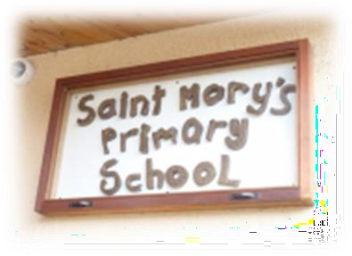
St Mary’s Primary School is a maintained primary school in the Parish of Kildress, in the town land of Dunamore near Cookstown in County Tyrone. The children attending the school come mainly from the surrounding and wider rural area.

Over the past 50 years the school has
experienced many changes from a three classroom school (built in 1963) to a seven classroom school now. Extensions in 1984 and more extensions and refurbishments from 2009-2015 have updated and modernised the school to include a new mobile classroom, a hygiene Room, a refurbished Computer Suite, a new P7 classroom, an extra resource room and a reading centre.

The enrolment has remained consistent over the past four years. The percentage of children entitled to free school meals and the proportion requiring additional help with aspects of their learning have both decreased over the same period.

At its last inspection (September 2015) St. Mary’s was deemed to have a high level of capacity for sustained improvement in the interest of all the learners.

In relation to ‘Achievements and Standards’ the ETI noted that;

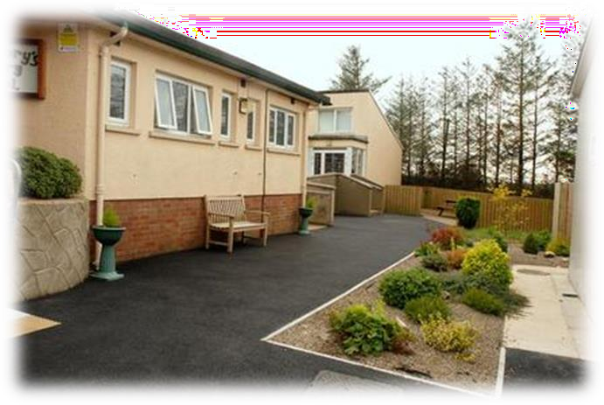
“Across the school, the children enjoy their learning and almost all contribute confidently to whole-class and group discussions. As they progress through the school, they share and discuss their ideas with increasing maturity and listen
respectfully and respond sensitively to the views of others. From an early age, the children show a positive attitude towards and interest in books, using a range of strategies to support their reading.”

“The children in the foundation stage are developing and increasing their confidence in investigating mathematics within their environment. As they progress through the school, they demonstrate a good knowledge and understanding of key mathematical concepts and can apply these to real- life contexts across the curriculum.”

“The children use information and communication technology (ICT) with increasing confidence and complete a range of tasks which allow them to develop their thinking skills and personal capabilities. They use a range of devices to enhance their learning and develop their creativity.”

In relation to ‘Provision for Learning’ the ETI noted that;

“The lessons observed were effective in promoting and progressing the children’s learning. In these lessons, the teachers built successfully on the children’s prior learning, the activities were well matched to the children’s needs and interests and they were given time and support to reflect on and develop their responses. While the teachers apply a consistent approach to planning across the school, they demonstrate flexibility in their teaching in order to respond to the needs and interests of the children.”

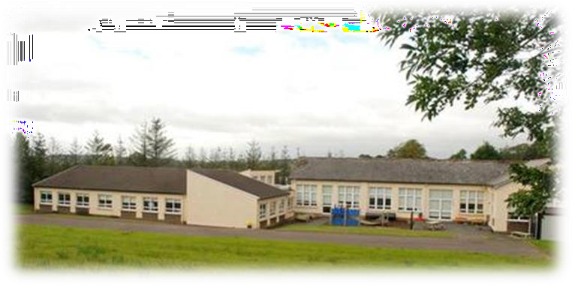
“The inclusive learning environment supports very well those children who require additional
support with aspects of their learning. Through rigorous tracking of the children’s progress, appropriate, short-term intervention programmes for both literacy and numeracy
are put in place to address potential barriers to learning. The school has identified correctly the need to continue to monitor and develop further aspects of the provision. The classroom assistants work in close partnership with the teachers to provide skillful, sensitive in-class support.”

“The quality of pastoral care is outstanding. This provision is characterised by the child-centred ethos, the very good working relationships between the staff and the children, a well-delivered preventative education curriculum and the effective engagement with external agencies to meet the needs of all the children. The children’s

social and emotional development is given a high priority and their achievements are recognised and celebrated. Through the student council, the children undertake important roles and responsibilities and contribute meaningfully to the improvement of their school.”
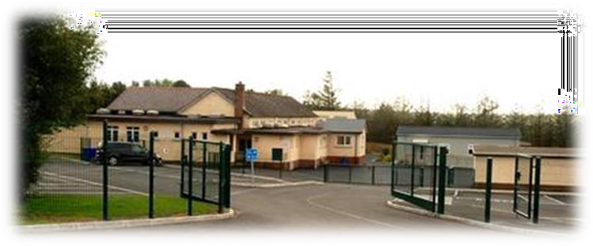
In relation to ‘Leadership and Management’ the ETI noted that; “The senior leadership
team is committed to
meeting the individual needs of all the children and to raising further the standards they achieve.”

“The co-ordinators are skilled in monitoring and evaluating the provision for learning and standards within and across their areas of responsibility; they share willingly their specialist knowledge with their colleagues to support them in their work.”

“The school works in partnership with the parents regarding their children’s learning and values the contribution of the wider community to the life and work of the school.”

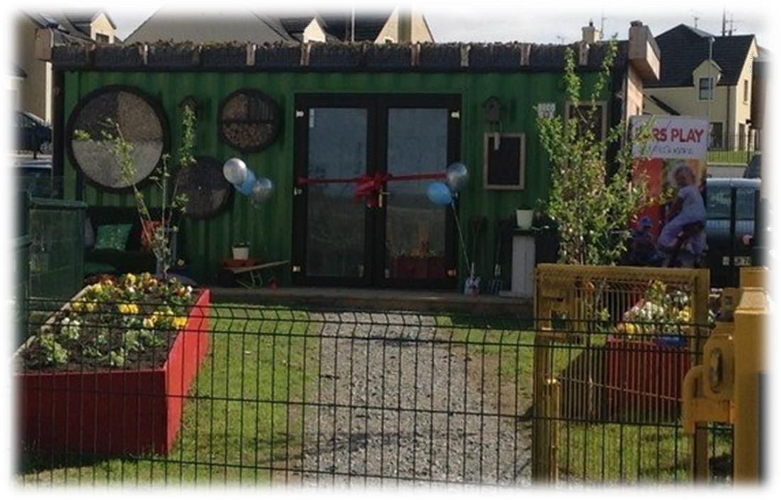

Here in St. Mary’s PS, all pupils receive their full entitlement under the Northern Ireland Curriculum. It is our aim that we will empower young people to develop their potential and to make responsible choices and decisions throughout their lives.

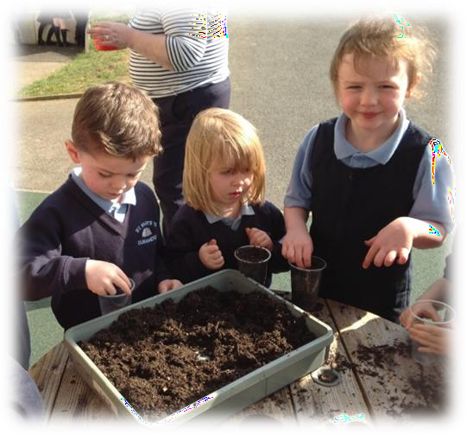
The Primary curriculum is set out in three stages:
♣ The Foundation stage; Primary 1 and 2
♣ Key Stage 1; Primary 3 and 4
♣ Key Stage 2; Primary 5,6 and 7.

The Curriculum for the three stages is set out in seven Areas of Learning.
- Communication
- Using Mathematics
- Information and Communications Technology (ICT)
- The Arts
- The World Around Us
- Personal Development and Mutual Understanding
- Physical Education

Communication includes Talking and Listening, Reading and Writing. There are a lot of skills that a child needs to have in place before s/he begins to read. Again you can help this process in many ways.

  - Talk to your child and answer questions
  - Encourage your child to listen to you and answer your questions
  - Read and share books with your child.
  - Make your child aware of print everywhere… in shops, road signs,
posters and newspapers.
  - Teach your child nursery rhymes; they are a great help with rhyming.

Your child will be given pre-reading books first. Talk about the pictures and the stories they tell. Look at the front cover and talk about the title. Basically do anything you can to help your child enjoy and develop an interest in learning to read.

‘Using Mathematics’ is the skill of applying mathematical concepts,
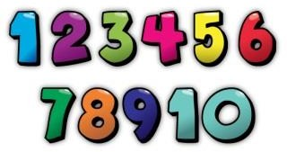
processes and understanding appropriately in a variety of contexts. Ideally these should be in relevant real life situations that require a mathematical dimension. As Mathematics and Numeracy are one of the core subjects in the NI Curriculum, great emphasis is placed on it. There are many ways you can help your child
develop the early skills in this Area of Learning, for example;

  - Point out colours

  - Point out numbers around us

  - Give your child items to count and sort, e.g. socks, cutlery, beads, money, sweets, items in the shopping and so on.

Pupils will develop the skills of Using ICT (Information and Communications Technology) by engaging in meaningful research and purposeful activities set in relevant contexts.
They will use ICT to handle and communicate information, solve problems, pose questions and take risks. They will process, present and exchange their ideas and translate their thinking
into creative outcomes that show an awareness of audience and purpose. The classrooms have all been equipped with Interactive Whiteboards, and two computers. A wireless ICT suite has been established and there are ten iPads allocated to each class.

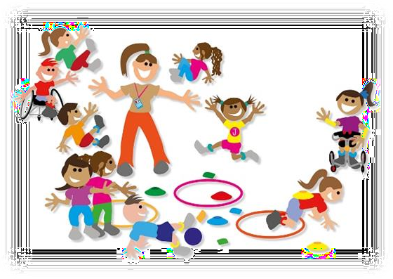Your child/children will be able to participate in activities to promote fitness and thinking skills.

The key areas are;
- Games
- Gymnastics
- Dance
- Athletics.

In St. Mary’s we have developed a thematic approach to teaching and
learning within the area of ‘The World Around Us.’

Through the Thematic Curriculum children learn across the Learning Areas of The World Around Us (Science, History and Geography) The Arts and PDMU.

They have relevant and interesting opportunities to deepen and develop their learning in Literacy, Numeracy and ICT too.

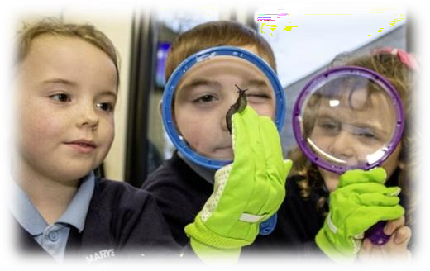
In P1 we will be working on the themes:
- Hey Hey Look at me!
- A Time to Rhyme
- In the Toybox
- Let’s Get Growing
- Splish Splash Splosh.

The Arts consist of Music, Drama and Art. All work covered in P1 is reinforced by music and art. The children will experience a range of Art lessons including papier mâché, painting, modelling, sponge prints etc.

Music again plays its daily part in P1 and there are several programmes available to us. E.g.
Music Box Wood and Singing Time. The children have a chance to perform their songs and music in class daily, at assemblies and plays etc. throughout the year.

The PDMU curriculum helps children foster attitudes and dispositions which will enhance their experiences in life. These include; personal responsibility, concern for others, commitment, determination, resourcefulness, openness to new ideas. Self-confidence, curiosity,
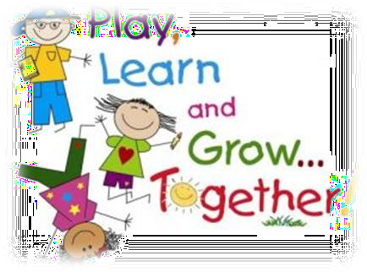
community spirit, flexibility, tolerance, integrity, moral courage and respect.

The child is at the centre of all activities in the PDMU area of learning. We concentrate on their development to make informed choices as responsible members of society.

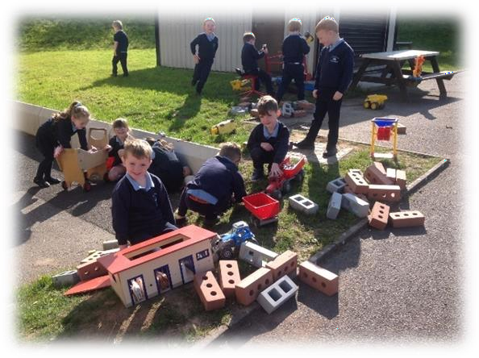
Young children come into school from a variety of backgrounds, having had a range of diverse learning experiences at home and for most some form of pre-school education. The Foundation Stage (P.1 & P.2) builds upon these learning experiences by
providing children with an appropriate learning programme to develop their dispositions to learn and the skills and competencies they will need to succeed in school and future life. Play is a core aspect of learning in P.1 and P.2. It is how children become aware of the world around them and how they continue

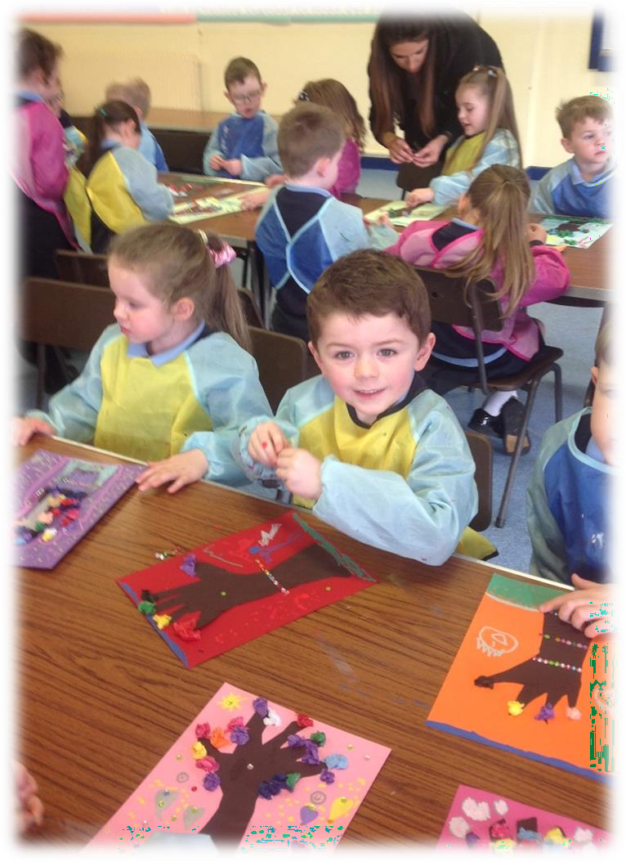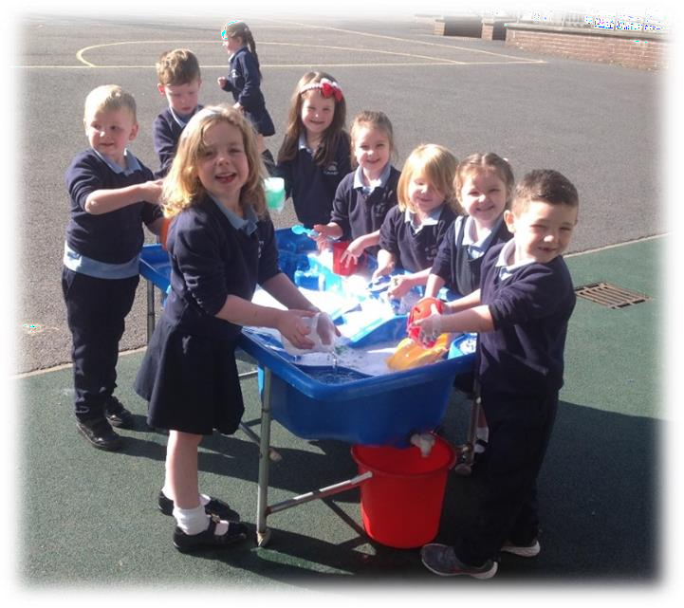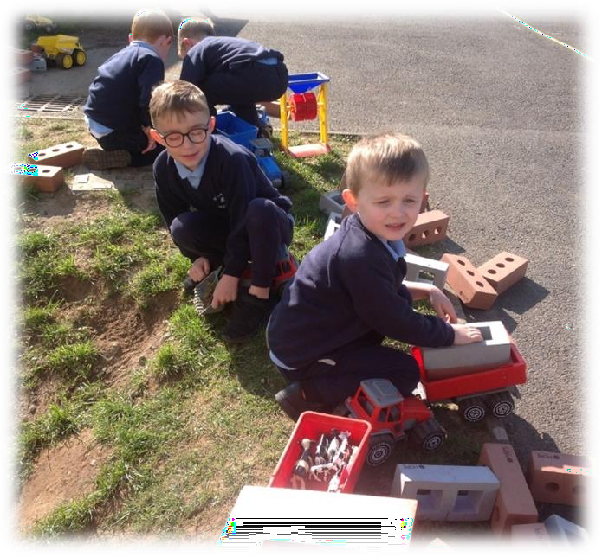to discover and develop. It is the vehicle for our children to develop the skills they will need to become confident and independent learners.

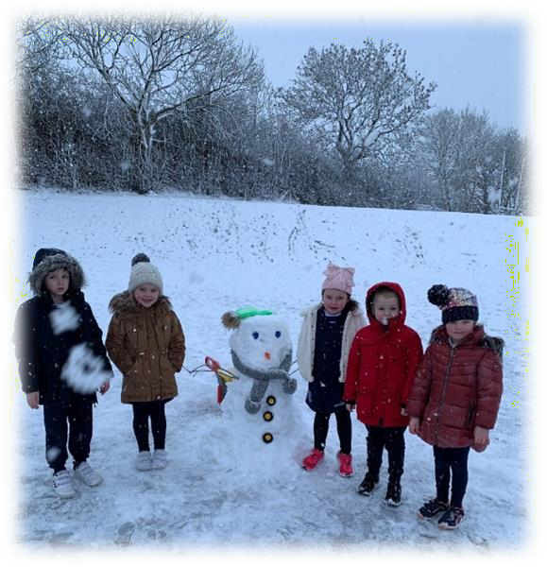
There are many different types of play and in P.1 we try to give the children a broad and balanced range of play activities.
Throughout the year they will develop the skills of sharing, turn taking, talking and listening to others, cooperating with and organising, leading and following.

As a Catholic school our ethos pervades all aspects of school life. Each child feels welcome, cared for and respected. We have God at the centre of everything.

We are concerned not only with helping each child to realise their potential academically and physically, but to develop emotionally and spiritually in order to play a role in the wider community and beyond.

We follow the ‘Grow in Love’ programme, which strengthens the spiritual life and develops in the children a loving, caring attitude towards each other as well as a deepening and personal relationship with God.

In practice, a faith filled life involves celebrating the Mass as a school community at various times during the year. School Liturgies are celebrated at the beginning and end of the academic school year. The sacraments of Penance, First Holy Communion and Confirmation draw together school and parish and unite all participants in the moral and spiritual welfare of the children.

School Assemblies for all Key Stages play a vital role in school life helping to form children’s characters and shape their ideas as Christian young people.

Prayers are an integral part of life in our school and each class takes it in turn to prepare and present an assembly each month. The school day begins and ends with prayers and as well as the daily RE lesson, there are
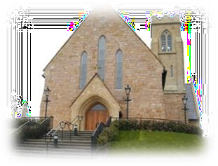
class prayers services.

We maintain strong links with the priests of the parish and so home, school and parish are united in passing on the Catholic faith and traditions.

The Diocesan Adviser for Religious Education visits the school annually and the school chaplain Fr Hughes visits the school regularly and supports the delivery of the RE programme.

With parents as the first educators we ask you to please teach your child to bless him/herself and go over the prayers we say every morning and at home time.

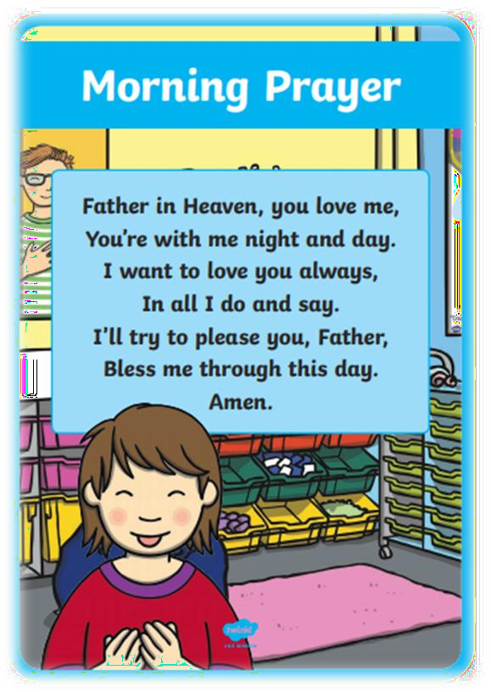
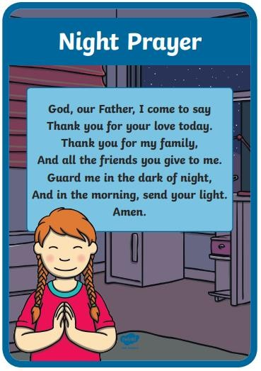
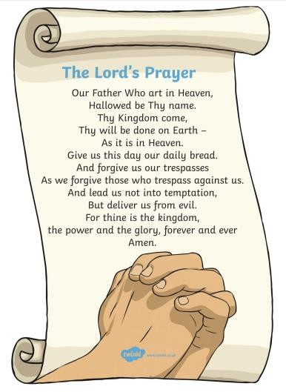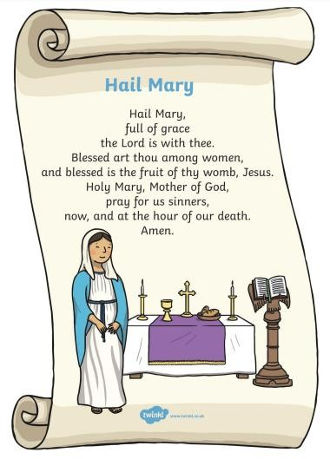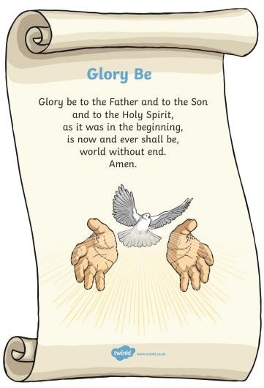

Our catholic values enable us to educate the children in a safe, secure and happy environment where all adults and each child is treated with respect and valued in a spirit of Christian love.

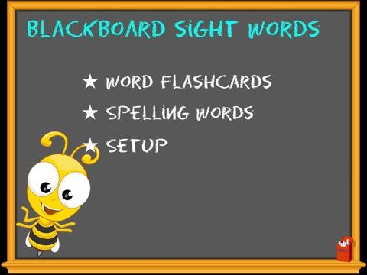
P1
P2
P3 - P7
Hometime
2:00pm
2:10pm 3:00pm
8.30am- School Opens

8:45am – 9.20am – Morning Routine 9:20 am - Class begins
10:30 am – 10:45 am - Break 10:45am – 12:15pm - Class 12:15pm – 12:55pm – Lunch (P1-P4)
12:35pm – 1:15pm – Lunch (P5-P7)

School Terms
Autumn Term – September to December Spring Term – January to April Summer Term – April to June

Primary 1 children will start on Thursday 31st August and remain in school until 12Noon. Their first full day will be Thursday 14th September and they will go home at 2pm.
We would ask that your child is in school for 9.20am and collected at 2pm

Absenteeism
We are required to keep detailed records about a child’s attendance in school. If for any reason, your child is sick, please inform the school explaining the reason for this absence. The Education Authority’s Education Welfare Officer (EWO) also keeps a very close eye on children’s attendance and punctuality. Where there is a concern
about a child’s attendance, the EWO will make further
inquiries concerning the reason for the absence.
Data Collection and Contact Details

It is important that all parents/guardians complete and return the Data Collection forms that will be issued in September. This ensures that we can contact you in an emergency, for example, if your child is unwell. Please inform the school office by phone or email if there are any changes to these details so we always have the correct information.

Medical Information
Please inform the school if your child has a medical condition or any allergies. This can be done by completing the relevant sections in the Data Collection form. You can also speak to a member of our leadership team to discuss any specific arrangements required to support your child. Medicine can also be administered at school following completion of the relevant forms.

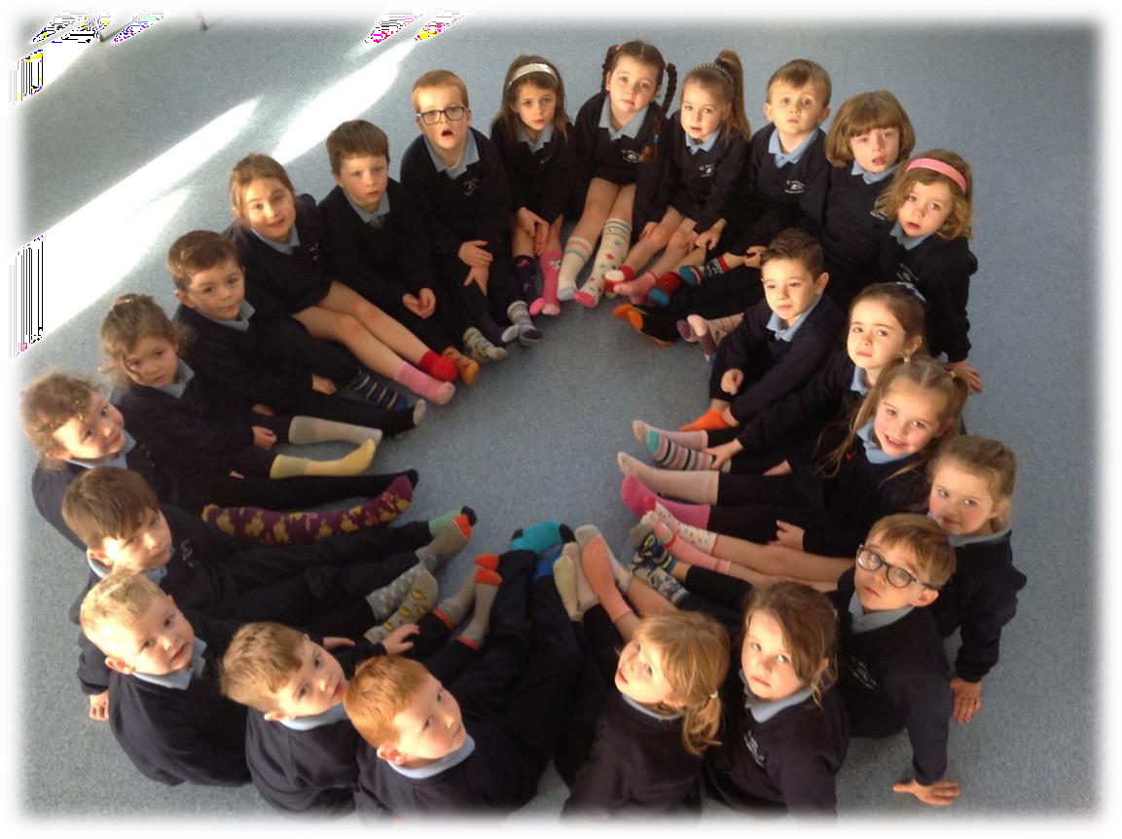

The wearing of our uniform is viewed as a way of demonstrating pride in our school and community.

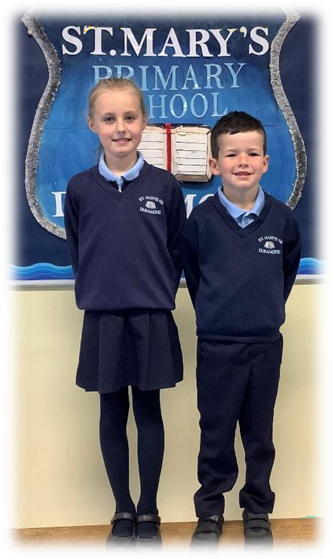
Pupils are encouraged to wear full school uniform at all times. It consists of:

o Navy Sweatshirt with crest.

o Blue polo shirt.

- Navy trousers for the boys and navy pinafore or skirt for the girls.

- As an alternative the girls may wear a navy cardigan.

- During the winter months, girls may wear trousers as part of the uniform.

- An optional waterproof fleece is now available.

o Black shoes & trainers.

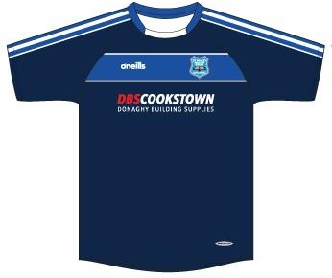
On the days children have PE, they should come to school dressed in their PE uniform.

The PE uniform consists of:

- School sports jersey,

- Navy shorts/tracksuit bottoms.

All clothing MUST BE CLEARLY
MARKED WITH THE CHILD’S NAME.

It is easy to return items of clothing
which have been found if they have a name on them.

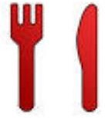

In St Mary’s, we believe that all pupils should be encouraged to live
healthy lifestyles. We are a Health Promoting School.

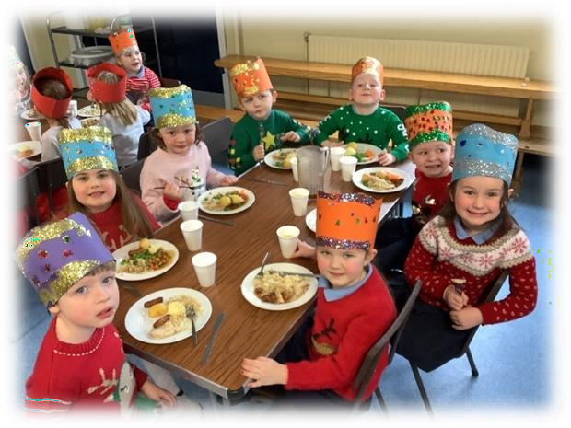
St. Mary’s Primary School has its own kitchen and Marie, our cook ensures that dinners are served fresh daily and to the highest standards. The cost of school meals is £2.60 per child, per day. Dinner Menus are prepared by the cook in advance so that pupils and parents can make informed decisions.

Pupils who have special dietary needs will not be excluded in any way and every effort will be made to meet their dietary needs. Please contact the principal / unit catering supervisor to discuss further.

Whilst in the dining hall all
pupils in turn will come up to the serving hatch and make their own choice about which dinner they wish to choose.

Alternatively, lunches can be brought to school and eaten in the school dining hall.

All Staff / Supervisors are there to help out in any way they can so that lunch time is an enjoyable and social experience.

At break time children are encouraged to bring in Healthy Breaks to school
e.g. a sandwich, scone, pancake, bread muffin, wheaten, wrap, fruit yogurt, fresh fruit or raw vegetables thus encouraging ‘Boost Better Breaks’.

Children are encouraged to drink water throughout the school day. Water fountains are located in two different locations within the school. Pupils have the option to bring a reusable water bottle to school every day if they so wish.

In respect to those pupils who have nut allergies no food containing any trace of nuts or nut essences are allowed in school. This includes popular brands of chocolate spreads. We are a NUT FREE school.

We use a secure online payment system called ParentPay to pay for school meals, PE coaching, trips etc.

ParentPay offers you the freedom to make payments whenever and wherever you like, 24 hours a day, 7 days a week – safe in the knowledge that the technology used is of the highest internet security available.

What does ParentPay do?
  - Enables you to pay for school meals and other items such as school trips.
  - Offers a highly secure payment site.
  - Gives you a history of all the payments you have made.
  - Allows to create a single account login across all your children that attend a ParentPay school.
  - Shows you all items available for payment relevant to each of your children.
  - Emails a receipt of your payment to the email address you register.
  - Offers you the ability to set automated email/SMS payment reminders.

How does ParentPay help you?
  - Gives you the freedom to make payments to school whenever and wherever you like.
  - Gives you peace of mind that your payment has been made safely and securely.
  - Payments for many of the larger trips can be made by instalments up to the due date.
  - ParentPay is quick and easy to use.

How do I get started?
We will send you an activation letter containing your activation username and password to enable you to setup your ParentPay account.

During the activation process you will be guided through changing your username and password to something more memorable; if you have more than one child at a ParentPay school/s you can also add children to a single account providing one login for all children at ParentPay schools.

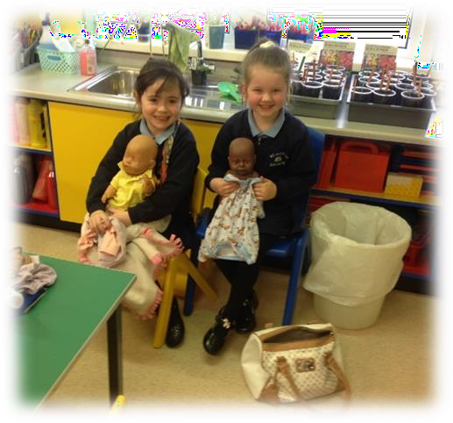
The transition from the home environment to school may represent a very big change for your child. The staff understand this, and they will try to make the transition as easy as possible.

There are some things which you can do to help ease the “ordeal” for the apprehensive child.

- Try to ensure that your child is unhurried each morning as they prepare for school.
- Make all preparations for school the night before if possible and avoid last minute rushes to gather up items.
- Make sure that they have a breakfast which will sustain them throughout the morning.

Most children make the transition in the first few weeks quite easily. Don’t be too worried if your child cries or doesn’t want to go to school after a few days. This happens from time to time but be reassured their upset wears off very quickly when they see the morning classroom routine unfold.

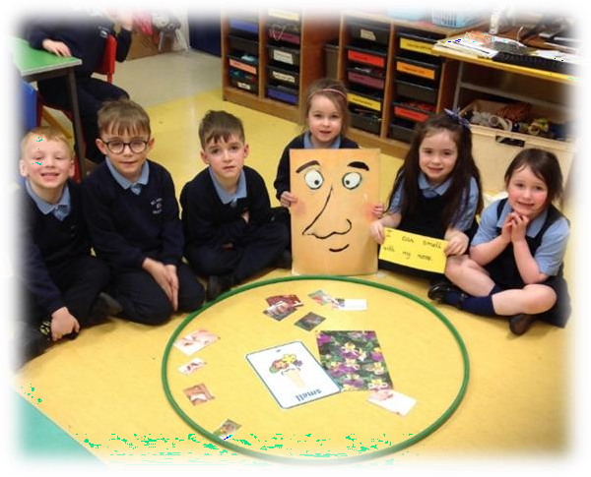
The Primary 1 classroom is a very busy place, with lots going on but most importantly each day brings a regular schedule and routine, which is extremely supportive, rewarding and comforting to the 4 and 5-year-old child.

Your child will soon get to experience and know the daily class routine, from the morning welcome, prayers, calendar, weather, phonics, active learning, healthy snack and tidy up (and that’s just to break time).

Each day will have a regular pattern that the children will recognise and respond to, building their confidence and their love of learning.

Talking and listening, reading and writing, skills are key to learning in
  - They are also the gateway to developing a love of learning, enjoyment and personal growth. These all-important life skills are developed in class through a variety of fun and interactive teaching
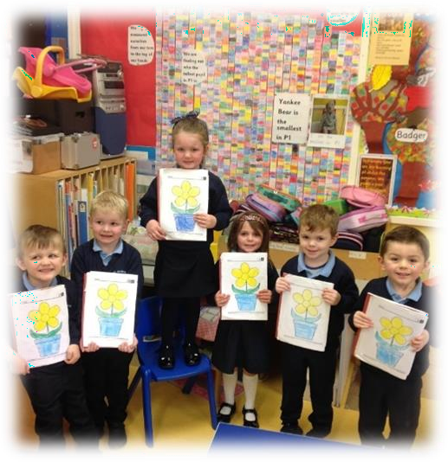
methods, including songs, rhymes, stories and of course active learning.

Children will engage in different kinds of mathematical learning, including, exploring and investigating number and pattern. They will also talk about what they have learned and ask questions about what they see. All of this active learning builds confidence in numeracy – again an important life skill.

So please don’t be worried or disappointed if you get the traditional
answer to the question…

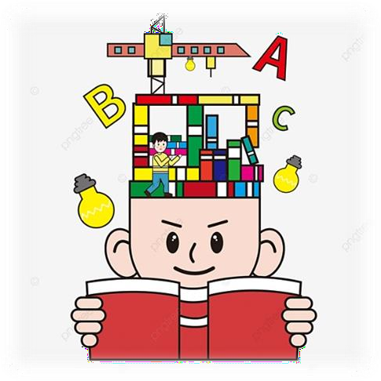
Primary 1 is the building block to successful learning. We spend significant time ensuring that this early learning and reinforcement of sounds/letters/rhyme/letter & number
formation/high frequency words/counting/is done to support the young learner, to develop their confidence, their independence and their ‘can do’ attitude so that there is a built-in readiness and eagerness to learning. We want them to be ready for reading/writing/counting/adding etc. rather than being discouraged and put off by starting too soon.

Regularly read them stories.
Listen and talk to them willingly - introduce really big and exciting words!
Answer their questions (even the awkward ones) or help them find out the answers themselves.
Sing nursery rhymes and songs with them. Point out interesting things to them.
Encourage them to play with toys and all sorts of materials, for example Lego, sticks, pebbles, coins and dough.

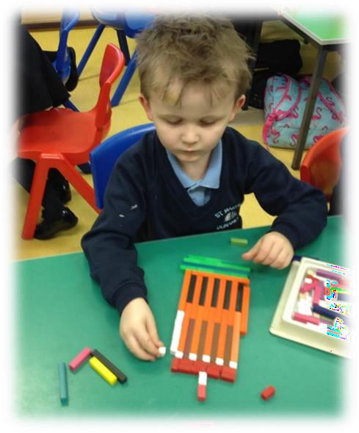
Play and take turns with other children. Tidy away their own toys.
Use the toilet independently. Blow their nose.
Begin to fasten their coat buttons, do up their zips, put on gloves and shoes as well as fasten their school bag.
Wash and dry their hands.
Recognise their own belongings.
Begin to use a knife and fork (or manage their own packed lunch).

Seesaw is a simple way for teachers and students to record and share what's happening in the classroom. Seesaw gives students a place to document their learning, be creative and learn how to use technology.

Each student gets their own e-portfolio and will add things to it, like photos, videos, drawings or notes. When there are new Seesaw posts, families can be notified via app notification, email or SMS.

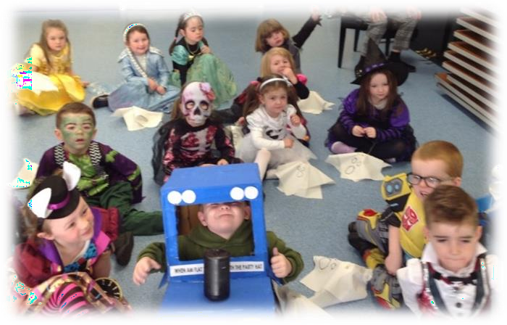
Parents are only notified about their own child’s work, and all data is safe and secure.

The app will also provide an opportunity to communicate with the class teacher and share news in an environmentally friendly and secure way.

There are many benefits to using this app:
    - Teachers will upload posts about pupil’s learning and achievements
that can be shared with their parents.
    - Class teachers can send messages and reminders to parents via the app.
    - Homework, curricular flyers etc. can be posted for pupils and parents to see.
    - Parents can set up the app on their personal devices and access
their child’s posts.
    - Seesaw is private; you will only see posts created for your child.

Each child will be issued with their own personal invitation as soon as possible and QR code to access their Seesaw portfolio. Please keep all codes and passwords secure.

At St Mary’s Primary School, we always strive to work in partnership with parents and encourage them to be involved in the life of the school.
The parents of Primary 1 and Primary 2 collect their children from school. This creates many opportunities for brief, informal communication with the class teachers.
Parents are very welcome in the school. The Principal and teaching staff are available to deal with concerns or queries. You can ring the school office to make an appointment.
Parents are invited to attend Parent Teacher Meetings in Term 1 and in Term 3 parents receive their child’s annual report. The teaching staff are available to discuss the report.
Parents are kept informed of school events through Seesaw, the school jotter app, regular notes and letters, information leaflets, a monthly newsletter and the school website.
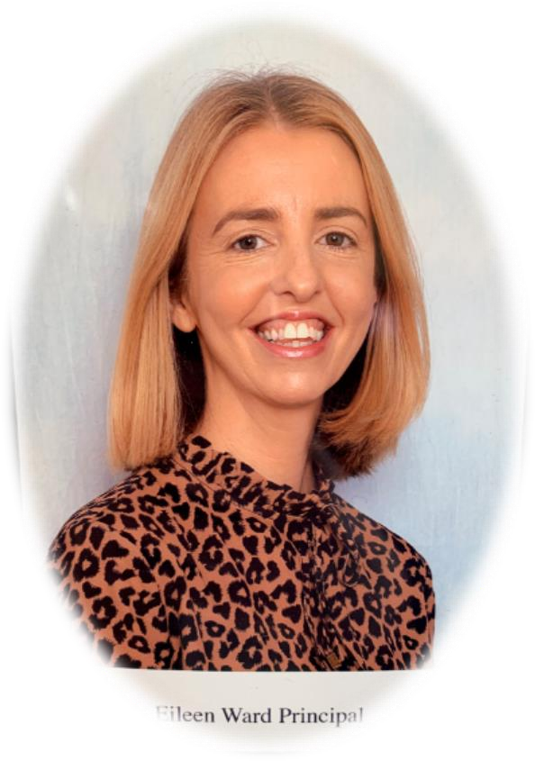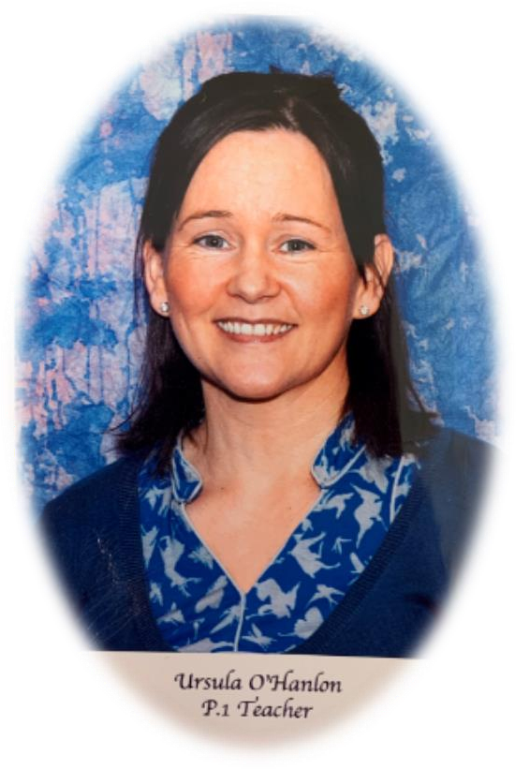
Mrs Eileen Ward
Principal
Principal

Mrs Ursula O’Hanlon
Primary 1 Teacher

We look forward to seeing you in September and starting a new learning journey together!

