
ST. MARY’S PRIMARY SCHOOL
Principal: Mrs Eileen Ward B.Ed (Hons) M.Ed, PQH (NI)
028 867 51357 eward387@c2kni.net

Monday 29th January, 2024

Dear Parents,

We are now at the stage to begin thinking about the transfer procedure and applying for a place in post primary school.

Applications this year are all ONLINE and the portal will open at 12noon on Tuesday 30th January and close at 12Noon on Thursday 22nd February. It is not a first come first served basis.

The admissions criteria for each Post Primary School is now available on the EA website (https://www.eani.org.uk/search-schools ). Please read carefully through all the criteria that schools have published and in particular schools that may be of interest to you and your child.

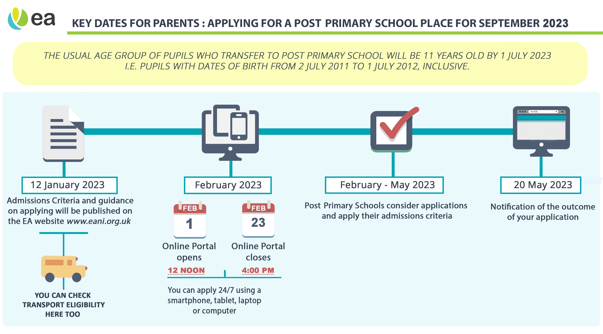
All the necessary information and a helpful video is available at:

https://www.eani.org.uk/parents/admissions/post-primary-admissions-guide

It is important to consider transport for your child and you can check eligibility on the EA Website.

It is worth noting that children are not always placed in their first preferences. Therefore, it is recommended that you list at least four schools on your online application.

If you have any questions or would like a meeting to discuss, please do not hesitate to contact me and it can be arranged.

Kind Regards,

Eileen Ward
Principal

